OFERTA1
CAMARA DLINK DCS-930L=289 SOLES
INSTALACION =120 SOLES

FICHA TECNICA:http://www.onedirect.es/files/Dlink/DCS-930L_PDF_GB.pdf
VIDEO: https://www.youtube.com/watch?v=cI__ePuf0Zs
INSTALACION: http://www.dlink.com/-/media/Consumer_Products/DCS/DCS%20930L/Manual/DCS_930L_A1_Manual_v1_20_ES.pdf



OFERTA2:
Nexxt Solutions Nexxt XPY-300= S/.389
INSTALACION= 120 SOLES

FICHA TECNICA:
http://www.nexxtsolutions.com/pe/downloads/dl/file/id/248/ailr6324u1_xpy_300_ip_camera_specifications_ds_eng_lr_03_21_2012.pdf

VIDEO: https://www.youtube.com/watch?v=9DVko7JpJR0

INSTALACION: https://accvent.desk.com/customer/es/portal/articles/1210022-camaras-ip-configuracion-basica

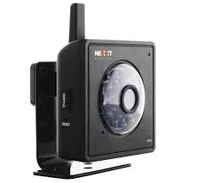

OFERTA3:
Nexxt Solutions Nexxt XPY-320= S/.399
INSTALACION= 120 SOLES

FICHA TECNICA: http://www.nexxtsolutions.com/pe/downloads/dl/file/id/207/ailr6324u1_xpy_320_ip_camera_specifications_ds_spa_lr_03_07_2012.pdf
VIDEO: https://www.youtube.com/watch?v=qrVBZ_TCcRA
INSTALACION: https://accvent.desk.com/customer/es/portal/articles/1210022-camaras-ip-configuracion-basica

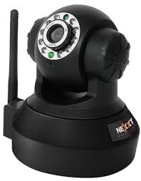

OFERTA4:
Nexxt Solutions - nexxt XPY510 PT=S/.420
INSTALACION = 120 SOLES

VIDEO: https://www.youtube.com/watch?v=zf5MfgBxLQ4
FICHA TECNICA: http://www.nexxtsolutions.com/pe/downloads/dl/file/id/315/xpy_510ds_spa_hr_10_16_2013.pdf
MANUAL DE INSTALACION: http://www.nexxtsolutions.com/pe/downloads/dl/file/id/465/xpy_500_510_520_eng_manual_de_usuario.pdf
